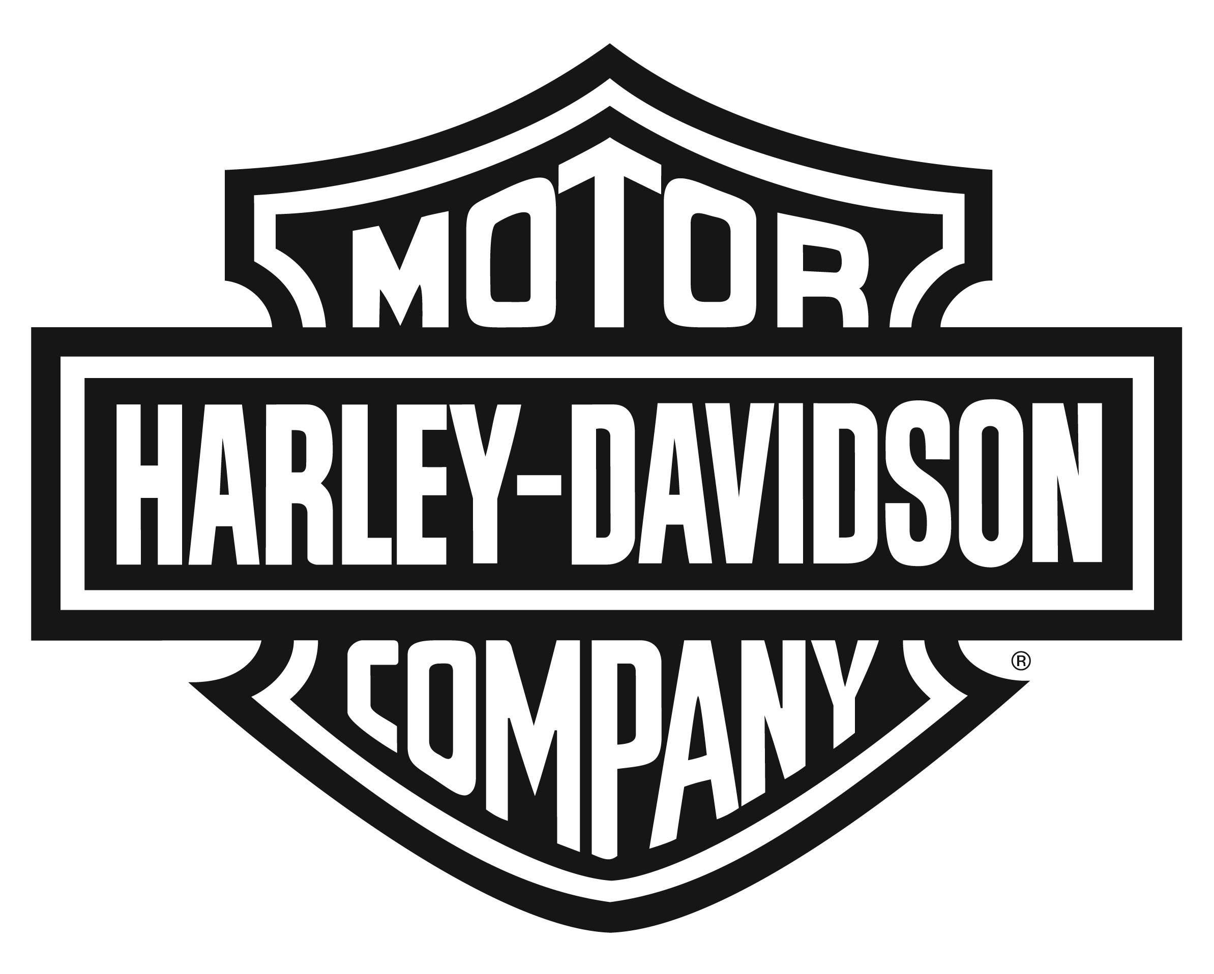

Harley-Davidson Motor Company 3700 W. Juneau Ave., P.O. Box 653, Milwaukee WI 53201

NEWS

Contact: Mike Roach (414) 343-4516

HARLEY-DAVIDSON REVEALS PROJECT LIVEWIRE™,
THE FIRST ELECTRIC HARLEY-DAVIDSON MOTORCYCLE
H-D Invites Consumers to Ride, React and Shape the Future of this New Bike

MILWAUKEE (June 19, 2014) – Innovation, meet heritage. Today, Harley-Davidson (NYSE:HOG) reveals Project LiveWire – the first Harley-Davidson® electric motorcycle.

In keeping with the company’s customer-led product development approach, starting next week select consumers across the country will be able to ride and provide feedback on the bike, helping to shape the future of Harley-Davidson’s first-ever electric motorcycle.

While not for sale, Project LiveWire is specifically designed for the purpose of getting insight into rider expectations of an electric Harley-Davidson motorcycle.

“America at its best has always been about reinvention,” said Matt Levatich, President and Chief Operating Officer, Harley-Davidson Motor Company. “And, like America, Harley-Davidson has reinvented itself many times in our history, with customers leading us every step of the way. Project LiveWire is another exciting, customer-led moment in our history.”
Spurred by this heritage, the Project LiveWire Experience invites customers to test ride, provide feedback and learn more about the story of the motorcycle. Even those who don’t yet ride will have the opportunity to feel the power of Project LiveWire through Jumpstart – a simulated riding experience.

A 2014 U.S. tour – kicking off with a journey down Route 66 – will visit more than 30 Harley-Davidson dealerships now through the end of the year. In 2015, the Project LiveWire Experience will continue in the U.S. and expand into Canada and Europe.

“This builds on many recent reinvention successes for Harley-Davidson.” said Levatich. “In just the last few years, we’ve broadened our reach to serve an increasingly diverse society, as well as reinvented our approach to product development and manufacturing. This has resulted in cutting-edge products like the recently launched Project Rushmore touring bikes, Harley-Davidson Street 500 and 750 models and this reveal of Project LiveWire.”

An Innovative Approach to Advance the Possibilities of Personal Freedom
This exciting new ride blends the company’s styling heritage with the latest technology to deliver a new expression of the signature Harley-Davidson look, sound and feel.

“Project LiveWire is more like the first electric guitar – not an electric car,” said Mark-Hans Richer, Senior Vice President and Chief Marketing Officer, Harley-Davidson Motor Company. “It’s an expression of individuality and iconic style that just happens to be electric. Project LiveWire is a bold statement for us as a company and a brand.”

The bike offers a visceral riding experience with tire-shredding acceleration and an unmistakable new sound.

“The sound is a distinct part of the thrill,” said Richer. “Think fighter jet on an aircraft carrier. Project LiveWire’s unique sound was designed to differentiate it from internal combustion and other electric motorcycles on the market.”

Longer term plans for retail availability of Project LiveWire will be influenced by feedback from riders along the Project LiveWire Experience tour.

“We offer a no excuses riding experience in everything we do and we are led by what our customers tell us matters most,” said Richer. “Because electric vehicle technology is evolving rapidly, we are excited to learn more from riders through the Project LiveWire Experience to fully understand the definition of success in this market as the technology continues to evolve.”

Helping Preserve and Renew the Freedom to Ride for Generations
As riding in the great outdoors is one of the best elements of motorcycling, sustainability remains a core strategic focus at Harley-Davidson.

“Preserving the riding environment is important to all of us,” said Levatich. “Project LiveWire is just one element in our efforts to preserve and renew the freedom to ride for generations to come. As a company that has seen success for 111 years, we think in generational terms about our great riding environments for the next 111 years.”

Fans can learn more about Project LiveWire, as well as specific dates and locations for Project LiveWire Experience stops at projectlivewire.com. Harley-Davidson also invites anyone who is interested in the possibilities of the future to follow and engage with the company on its social media channels, including Facebook, Twitter and Instagram.

Harley-Davidson Motor Company produces heavyweight custom, cruiser and touring motorcycles and offers a complete line of Harley-Davidson motorcycle parts, accessories, riding gear and apparel, and general merchandise. For more information, visit Harley-Davidson's website at www.h-d.com.

# # #

